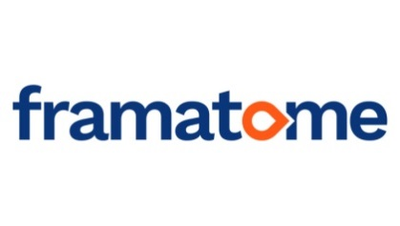
Framatome GmbH
Paul-Gossen-Straße 100
91052 Erlangen
http://www.framatome.com/EN/home-57/index.html
Deutschland
Tel.: +49 9131 900 91293

Language Student Placement for summer 2020 - summer 2021 in areas:

Fuel - Marketing and Sales (1 position available)
Installed Base - Project Management (2 positions available)
Installed Base – Business and Supply Chain (1 position available)
Instrumentation & Control – Project Management (1 position available)

Please note: All positions are in the area of Project Management. However, some roles have a more specific focus on certain areas and are therefore titled accordingly.

Job offer
Framatome GmbH, Germany, is offering a one year work placement/internship to German language students for the year 2020-21. The starting date during summer of 2020 is to be discussed during a telephone interview.

Role
The student would be expected to work in both English and German, performing a variety of tasks. General tasks include:
- Project development
- Proof-reading
- Technical translation
- Providing English lessons to members of the department (on a one- to-one basis)
- General office activities

Some role-specific tasks (according to role) include:
Fuel - Marketing and Sales: Management of product sheets and solutions portfolio, updating of Documentum (company-wide document database), production of new marketing (including digital) materials, support for upcoming events.
Installed Base - Project Management: Bid preparation and contract development are key tasks. This role is however more general to project management, allowing the successful applicant to develop areas of interest (to be discussed with supervisor).
Installed Base – Business and Supply Chain Placement: Use of Excel, time-scheduling and sequence planning for suppliers, coordination of communication channels.
Instrumentation & Control – Project Management – Bid preparation and contract development, change management, open point’s management, scope management and reporting (internally and externally).

The successful applicant will work closely with one of our project managers, completing tasks to support them.

This is a paid internship (approx. €1100 p/month)

Requirements:
1. Studying a language degree course with German as a main component
2. Year abroad must be a compulsory part of course of study
3. English as native language
4. Competent German language skills
5. Computer skills (competent with Microsoft Office Package)
6. Previous office experience is not compulsory but would be desirable
7. Technical background would be advantageous

Please email your CV (English or German) and a cover letter (German) by 31st Jan 2020 at the latest to Jamie Gamble at:

jamie.gamble@framatome.com

For any related queries please also contact Jamie Gamble at the above email address.

In your cover letter, please clearly state which role you are primarily applying to. If this role has been filled, you will still be considered for the other positions, as opportunities to develop your own personal strengths/weaknesses and interests are available in all roles.

NB: Candidates will be considered upon receipt of application, so early application is advised.

NB: Framatome would like to remind you that conclusion on an employment contract and/or employment conditions will be subject to the result of Brexit negotiations and at this time we cannot provide any guarantees in this respect.

